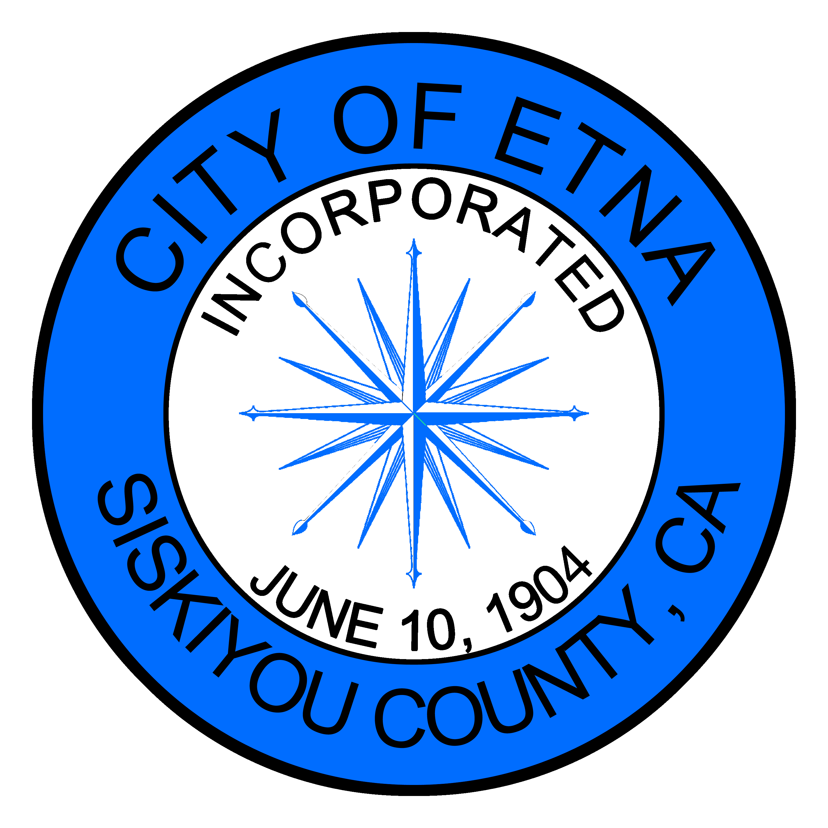
MINUTES
SPECIAL MEETING OF THE ETNA CITY COUNCIL
Monday September 27, 2021

Members of the Etna City Council met on this 27th day of September, via TELECONFERENCE. Mayor Jaime Tarne called the meeting to order and dispensed with the flag salute.
Roll Call
Councilmembers Cliff Munson, Charnna Gilmore, and Mayor Jaime Tarne were present. Councilmember Brandon Fawaz was not present.
Oral Comments from the Public on Non-Agenda Item
None
Consent Calendar
None
Council/Department Reports:
None
BUDGET ITEMS:
None
Current Business:
None
CLOSED SESSION: Pursuant to Government Code Section 54957:
Discuss Personnel Matters – The City Council by a unanimous vote approved accepting Ambulance Director resignation and appointing a new director for the Ambulance Department.

Respectfully submitted,
Jenny Bennett
Asst. City Clerk

