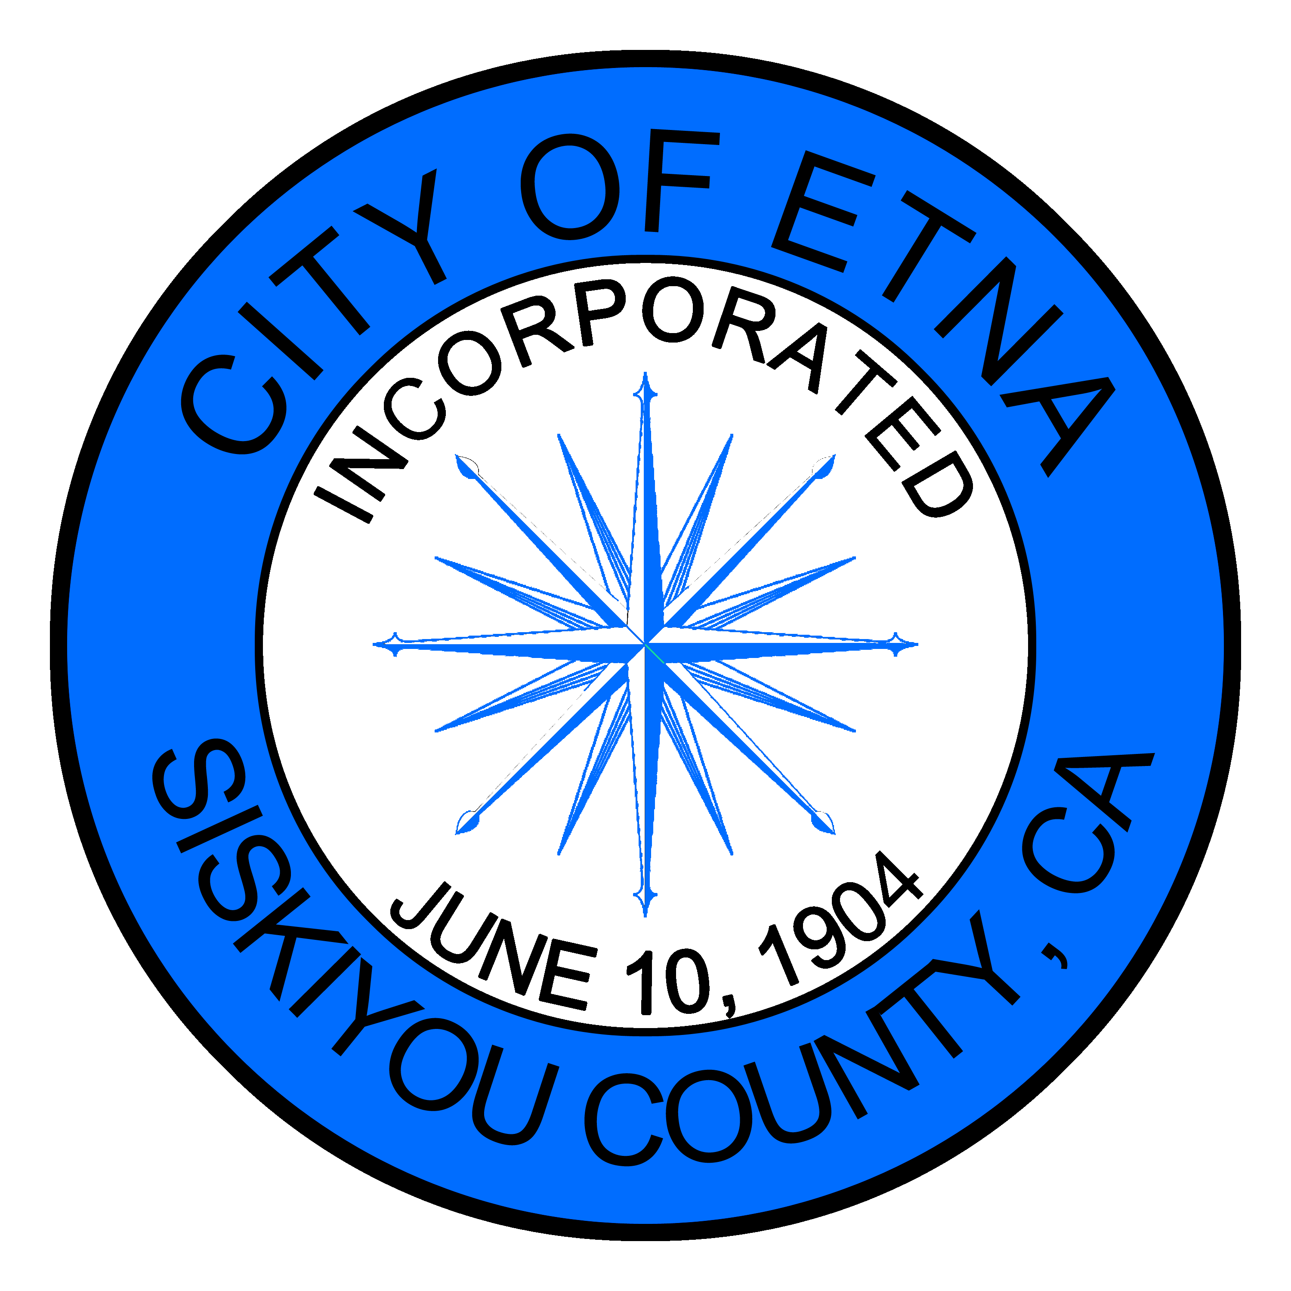
MINUTES
SPECIAL MEETING OF THE ETNA CITY COUNCIL
Thursday October 7, 2021

Members of the Etna City Council met on this 7th day of October, via TELECONFERENCE. Councilmember Cliff Munson called the meeting to order and dispensed with the flag salute.
Roll Call
Councilmembers Cliff Munson, Charnna Gilmore, and Brandon Fawaz were present. Mayor Jaime Tarne, and Councilmember Mitch Trost were absent.
Oral Comments from the Public on Non-Agenda Item
None
Consent Calendar
None
Council/Department Reports:
None
BUDGET ITEMS:
None
Current Business:
Discuss/Approve letter to Etna water users regarding City compliance with the State Water Resource Control Board (SWRCB) Curtailment Order.
Councilmember Gilmore explained the objective of the letter. Gilmore read the letter that will be individually addressed. A few edits/additions were suggested and noted.
Councilmember Fawaz recommended adding the phone number for the SWRCB to the letter for the community to call with questions regarding the order. Councilmember Munson agreed.
Councilmember Fawaz moved to approve the letter being sent to Etna water users with the addition of the SWRCB phone number, Munson seconded, and the motion passed.
Ayes: Fawaz, Munson, Gilmore
Councilmember Gilmore adjourned the meeting at 11:11 am
CLOSED SESSION: Pursuant to Government Code Section 54957:
None
Respectfully submitted,
Jenny Bennett
Asst. City Clerk

