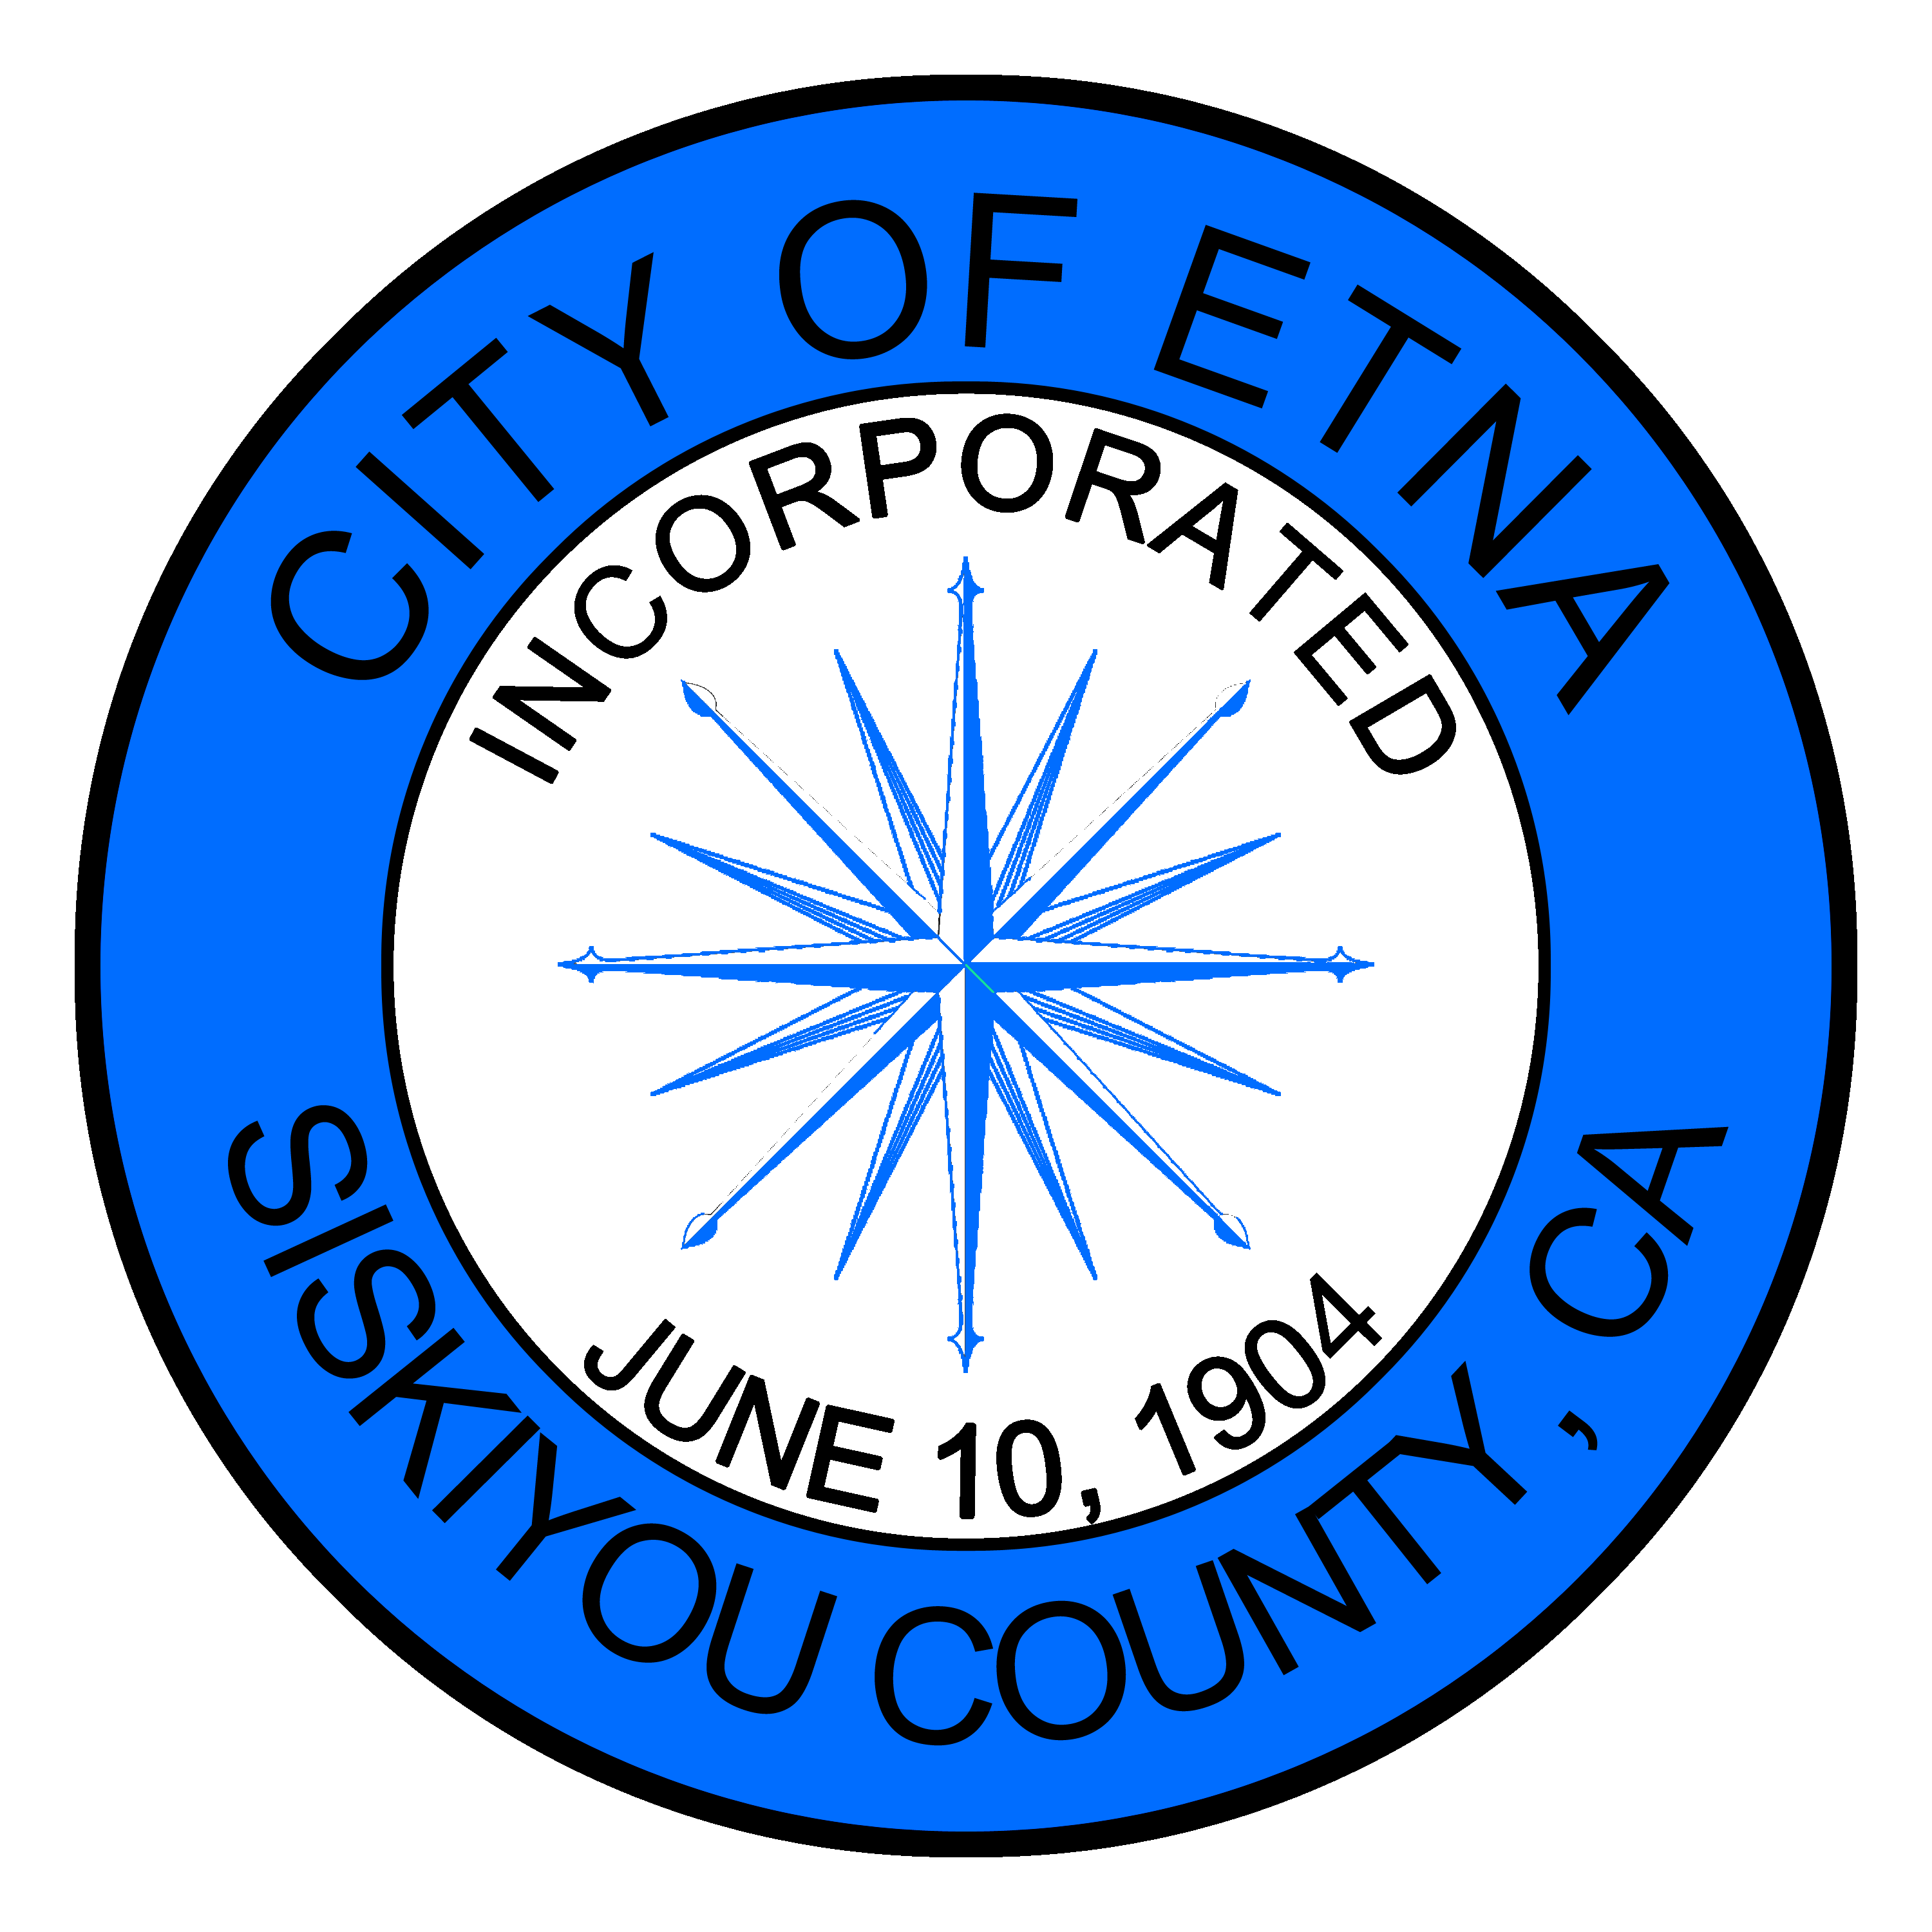
MINUTES
SPECIAL MEETING OF THE ETNA CITY COUNCIL
Tuesday September 14, 2021

Members of the Etna City Council met on this 14th day of September, via TELECONFERENCE. Mayor Pro-Tem Charnna Gilmore called the meeting to order and dispensed with the flag salute.
Roll Call
Councilmembers Cliff Munson, Charnna Gilmore, Mitch Trost, and Brandon Fawaz were present. Mayor Jaime Tarne was not present.
Oral Comments from the Public on Non-Agenda Item
None
Consent Calendar
None
Council/Department Reports:
None
BUDGET ITEMS:
None
Current Business:
None
CLOSED SESSION: Pursuant to Government Code Section 54957:
Discuss ongoing legal matters – The City Council by a unanimous vote approved City Clerk Kris Hargrove to sign on behalf of the city pertaining a legal matter.

Respectfully submitted,
Jenny Bennett
Asst. City Clerk

